Create a React.js/Next.js app using instructions as follows. Make assumptions if necessary. You can use logo, font and colors of your choice. You may use technology of your choice for backend or use static data shared.

- Have a login page as follows:
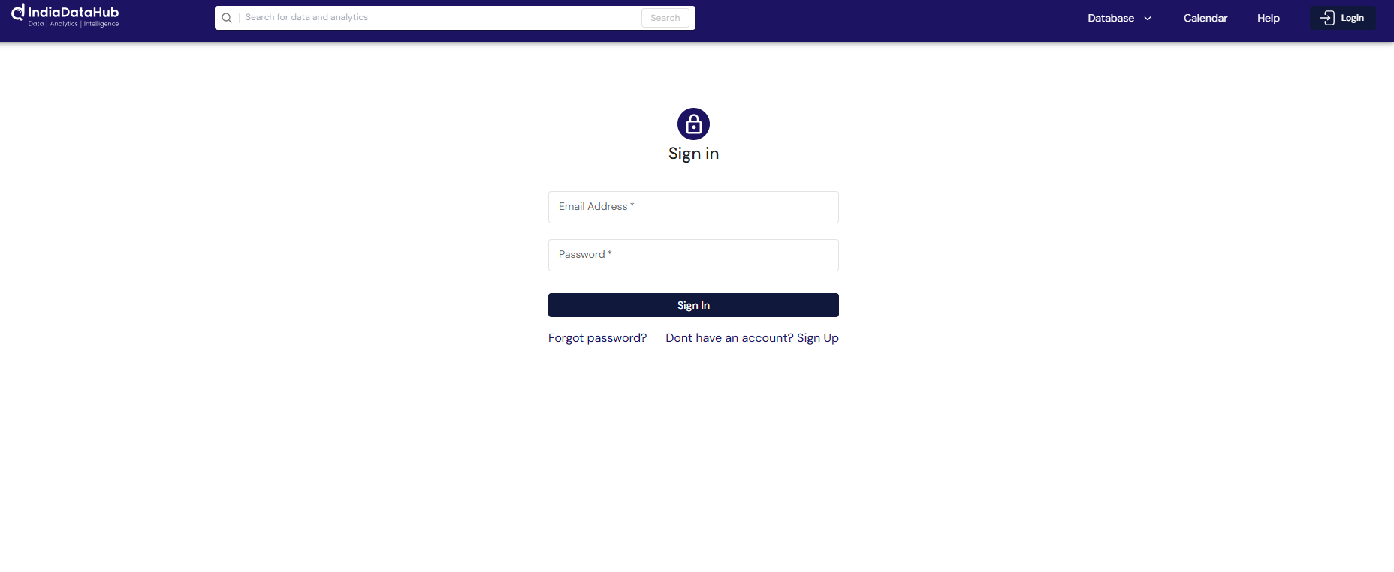
- On successful login, UI should be a product catalogue page as shown in Results image. (Instruction: Use the response1.json to populate the data. The structure of response dataset is as follows:
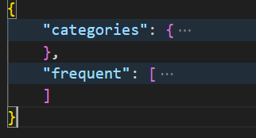
“categories” have the list of items shown in sidebar on the left. “Frequent” have the elements shown on the right pane. )

Results:
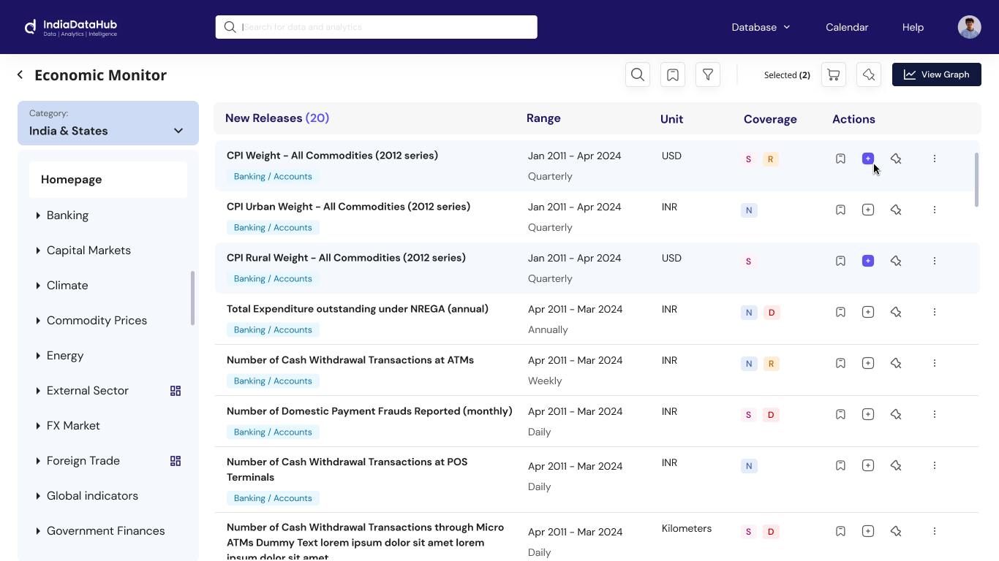

- Implement pagination such that only 10 records are displayed at one go.

- On selecting a new dataset-IMF as shown below, render data from the file- response2.json.
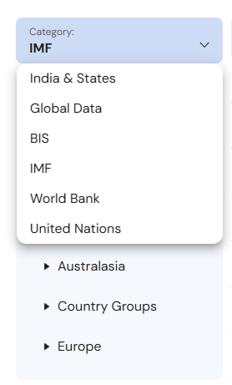

The dataset has large number of records, which makes the page slow to load. Device techniques to improve performance and load the results fast.

